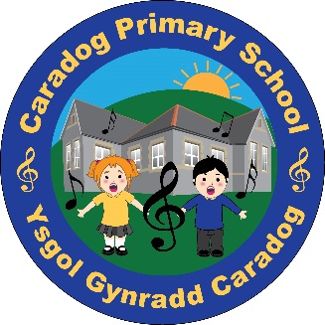

Can I access the information that the school holds about my child?
As a parent, and as having legal responsibility for your child’s personal data, you have a right to view the personal information that the school holds, regarding your child. In order to access this data you must complete a ‘Subject Access Request’ form, available to download from the school website or in paper format the school office. The school will then be able to arrange a time for you to be provided with this information.
Please note that in some instances, particularly where Child Protection cases are involved, you may not be entitled to view all information held on your child for legal purposes.

How will my child’s data be stored?
The Welsh Government, LA and School place a high value on the importance of information security and have a number
of procedures in place to minimise the possibility of a compromise in data security. The Welsh Government, LA and school will endeavour to work with you to ensure that information is kept accurate at all times. Personal information will not be sent outside of the United Kingdom or EU areas.
The school will always ensure that your child’s data is stored and disposed of securely.
CARADOG PRIMARY SCHOOL

What are my rights, and where can I get more information?
As a Parent, there a number of rights that are available to you regarding the processing and access to your child’s information. Full details regarding this, along with further information can be found by visiting the Information Commissioners Office at www. ico.org.uk. Likewise please visit the school website, or get in touch with the school with any questions or queries you may have.
Keeping your child’s data safe


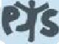
If you would like any further information regarding school policies at Caradog Primary School then please visit our website.
Likewise, please do not hesitate to get in touch with us so we can discuss these with you.
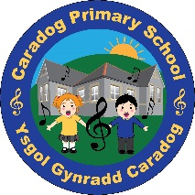
Caradog Primary school
Clifton Street,
Aberdare,
CF44 7PB
Tel: (01685) 874715
E-Mail: Admin.CaradogPrimary@rctcbc.gov.uk
Website: www.caradogprimary.co.uk


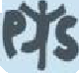
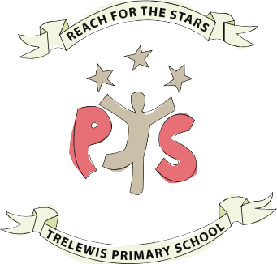

At Caradog Primary School we want to ensure that your child is able to make the best possible progress whilst at school. As part of this aim, we are required to hold various pieces of information about your child, so that we are able to best support them whilst at school. This can include reasons such as securing the safety of the child, as well as securing their on-going progress. This booklet aims to outline to you the ways in which the school collects, uses and deals with your child’s data during their time with us at Caradog Primary School.
  - Why does the school collect Personal Information?
The school collects information about pupils and their parents (or legal Guardians) when they enrol at the school. The school may also be required to collect other information at key times during the school year. Information is also received from other schools when pupils transfer. The school processes the information it collects to administer the education it provides to pupils. This includes:
    - Providing effective educational services to individuals;
    - Monitoring and reporting on pupils educational progress;
    - The provision of welfare, pastoral care and health services;
    - The giving of support and guidance to pupils, their parents and legal guardians;
    - The organisation of educational events and trips;
    - Planning and management of the school, including the health and safety of pupils.

  - What personal Information is held about my child?
As a school, we will only ever seek the information necessary for us to carry out our statutory role, and ensure that your child makes progress. The sort of personal information we hold will be the minimum required to carry out our work and includes:
    - Personal details such as name, address and date of birth;
    - Pupil Identifiers and contact details of Parents/Guardians;
    - Information regarding performance in internal and national assessments/tests
    - Information on the Ethnic origin,

national identify and language of a Pupil (this is only used to prepare summary statistical analysis);
- Medical Information (where necessary) to keep pupils safe whilst at school.
- Information on attendance and any disciplinary action (e.g. exclusions)
- Information about the involvement of social services with individual pupils, where this is needed for the care of the pupil (along with social service records for the child)

What is the lawful basis for the school holding my child’s data?
As a Public Body, we will seek and process your child’s information following the basis of ‘Public Task’ in line with UK Law. Any processing of information outside of this remit will fall under a ‘Consent’ basis. In such instances, you will be asked to sign and highlight your consent when providing the school with any additional information about your child.
In instances where Social Service are involved, it may become necessary for data to be processed in line within a ‘Legal Obligation’ basis. More information about the processing of data is available in our ‘Privacy Notice’ on the school website.

Will the Government have access to my child’s information?
The Welsh Government receives information on pupils normally as part of what is called the ‘Pupil Level Annual Schools’ Census (PLASC). The Welsh Government uses this personal information for research (carried out in a way that ensures individual pupils cannot be identified) and for statistical purposes, to inform, influence and improve education policy and to monitor the performance of the education service as a

whole. Examples of the sort of statistics produced can be viewed at www.wales.gov.uk/statistics.
The Local Authority (LA) also uses the personal information collected via PLASC to do research. It uses the results of this research to make decisions on policy and the funding of schools, to calculate the performance of schools and help them set targets. Any work is carried out in such a way that ensures individual pupils cannot be identified.
In addition, the Welsh Government and LA receive information regarding National Assessments and Test Results, as well as attendance data at a pupil level.

Will any other organisations have access to my child’s data?
Information held by the school, LA and Welsh Government on pupils may also be shared with other organisation where the law allows, for example with;
- Central South Consortium
- Other education and training bodies, including schools, for example when pupils are transferring to a different school;
- Central and Local Government Departments for the planning and provision of educations services;
- Social service and other health and welfare organisations where there is a need to share information to protect and support individual pupils;
- Various regulatory bodies, such as inspection authorities, where the law required that information be passed on so that they can do their work;
Where data is required to be shared with external organisations outside of these, consent will be obtained. The school will never pass on your child’s data for marketing purposes.

